MINUTES
Chatswood West Ward Progress Association Meeting
Dougherty Centre, 7 Victor St, Chatswood
April 2020 by email

Changed meting procedure
Due to the COVID-19 restrictions, the April meeting of the Association will be conducted by email. The Agenda, along with the Minutes of the March meeting and February and March Treasurer’s report were emailed to members on Friday 17 April 2020.

The only motion for consideration at this meeting is:

Move that the March 2020 Minutes and February Treasurer’s reports be accepted. Moved: Secretary Seconded: Treasurer.

We request that you acknowledge receipt and acceptance of the reports by a return email.

The responses will be used to determine the meeting attendance and quorum requirements.

Responses were received from 26 – the quorum was well and truly met members (maybe we should always hold meetings this way?) All respondents supported the motion that the Minutes and Treasurer’s Report be accepted.

Annual General Meeting: The Secretary will send out the papers for the AGM early next week.

Minutes: The Minutes of the March meeting have been distributed to members. Please indicate your acceptance of the Minutes and Treasurer’s report by return email.

Treasurer’s Report: The March Treasurer’s is included as an attachment.

REPORTS FROM COUNCILLORS
Written reports have been requested from Councillors.

Clr. Campbell pined: Re the 20 April council meeting, I do know that public input is still welcome, despite it being an online meeting. Anyone who would like to support / oppose or otherwise opine can send an email to council (or to me), and it will be part of the meeting in some form. I’m not entirely sure how it will all work yet, but I know that anyone who wants to be heard in the way they would normally be at a “normal” council meeting will be heard in this one in some form or another.

I would suspect many of the comments would be around the OH Reid action plan- have you had a look at that yet? The first I’ve seen of it is today, but at first glance it seems to make sense.

FEDERATION OF WILLOUGHBY PROGRESS ASSOCIATIONS & NSROC
The Federation has decided to continue operating via email with one vote per Progress Association.

GOVERNANCE
Plea for help by Mayor: The Mayor has called on Federal and State governments to implement a range of economic measures to address the financial impacts of COVID-19 on Council. This includes the:

- Impact of public health orders
- Viability of the Council workforce, and
- Financial assistance to offset Council stimulus provided to local businesses which included:
  - Rental relief - $573,000
  - Fee and license waivers - $600,000
  - Inspection waivers - $435,000, and
  - Fines waivers - $55,000

A total of over $1.6M.

Councillor superannuation: The Office of Local Government (OLG) has issued a Councillor Superannuation Discussion Paper and is seeking comments on the options in the paper by 8 May 2020. The paper is available at the OLG website https://www.olg.nsw.gov.au/programs-and-initiatives/councillorsuperannuation-discussion-paper/.

Annual General Meeting: Our AGM will be conducted by email. The papers for the meeting will be sent out by separate email.

Council meetings closed: Due to COVID-19 Council meetings are now closed to the public. However, they are webcast live. You can make a written submission on any matter before Council.

Mayor withholds casting vote: In relation to Clr. Saville’s recent motion regarding ‘fracking’ the vote was an equal number for and against. The Mayor had voted against the motion. The Mayor then elected not to use her casting vote. That being the case, the motion is deemed lost. This is the first time in decades (and perhaps in Council history that a casting vote, when available has not been cast.

When a vote is tied the Chair can cast a second vote to break the tie. It is completely up to the chair how that vote is cast. It can either be for or against the motion. In Westminster Parliament there is a ‘constitutional convention’ the second vote of the Chair is cast in favour of the status quo. However, under Council’s code of meeting practice this is not required.
To ensure meetings are open to the public, councils will be required to webcast their meetings. All councils have been required to webcast their meetings since 14 December 2019 under existing requirements.
Petitions
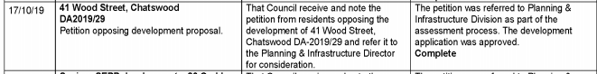

MAJOR LEGISLATION CHANGES
Fast-tracked development: NSW planning processes and development applications will be fast-tracked in a bid to support the construction sector and maintain jobs during the COVID-19 pandemic. Rezoning and development applications will be accelerated. More decisions will be made by the minister if required.
The Planning Minister, Mr. Stokes on Friday said the construction and development sectors were vital to keeping people employed and supporting economic recovery. Under the planning changes announced on Friday, the state government will also support councils and planning panels to fast-track local ... development applications.
Mr. Stokes said the so-called planning system acceleration program would create opportunities for more than 30,000 construction jobs in the next six months.
Virtual council meetings: The NSW Government has passed a Bill that amends the Local Government Act to allow councils to hold official meetings electronically instead of physically.
Virtual meetings will allow councils to continue to function and make decisions on behalf of their local communities while helping to reduce the risk of spreading COVID-19.
Under previous legislation, councillors had to be physically present at meetings and residents allowed to attend in person to watch them deliberate and make important decisions on behalf of the community.
For the next six months, these attendance requirements will be satisfied if council meetings are held remotely using audio visual links such as Skype. If that method is not available, council meetings will be able to be held in any other manner approved by the Minister.

Postponing Council elections: The NSW government has passed legislation that will allow the Local Government elections scheduled for September 2020 to be postponed.
The Bill provides the power for the Minister to postpone the local government elections for 12 months, with a possible further extension to 31 December 2021, should the need arise. This is a time limited power that will automatically expire after 12 months.

HERITAGE ITEMS
Heritage listings: The purpose of this report is to advise Council of the outcome from the exhibition of the Planning Proposal to list 8 properties as heritage items and to obtain Council’s endorsement to proceed with the amendment to Willoughby Local Environmental Plan 2012. Most of the properties proposed for listing are on the northern escarpment in Castlecrag. However, it is proposed to list the former Acoustics Laboratory (now Church of Scientology) at 126 Greville St, Chatswood. Submissions:

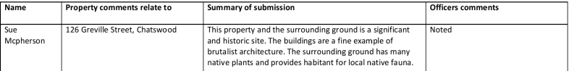

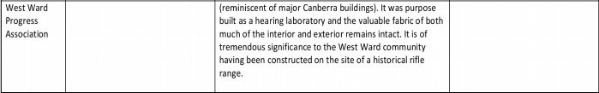

ENVIRIONMENT & OPEN SPACE
Brush turkey problem in Currey Park: We received the following response from Council:

We notice the unusually high number of Australiadevelon brush turkey in Currey Park and have been looking at this issue and considering how to address it.

The much maligned Australian brush turkey is of course a protected species and not to be harmed in any way. Therefore physical removal of any birds or their eggs is not only prohibited it would be unethical.

Instead we will be looking at modifying the environment to reduce activity where possible and stopping hand feeding of the young Australian brush turkey which has been going on for several months and seems to have discouraged them from dispersing which is what the young would normally do.

Action to modify environment:
· Removal of old nesting material – control future nesting
· Under pruning of garden parks plantings - control future nesting and discourage young to seek harbour in park
· Removal or minimising mulch in and around gardens – reduce foraging areas

Action to reduce artificial feeding
· In formation distributed to nearby residents
· Temporary sign discouraging feeding (attached) was installed last week but torn down/vandalised- will be replaced with a permanent sign next week
· Rangers will be asked to walk through and talk to feeders
· Seed left in park is regularly removed by maintenance teams

We welcome any suggestions or feedback.

Chatswood Golf Club: No report.

Coolaroo Reserve Action Plan: The Draft Coolaroo Reserve Action Plan is open for consultation. You can provide feedback through Council’s Have Your Say webpage using the link below:
https://www.haveyoursaywilloughby.com.au/coolaroo-reserve-action-plan.

Willoughby City Council is seeking community feedback for Coolaroo Reserve.

Please review the Draft Coolaro Reserve Action Plan in the Document Library and leave your comments below in the survey prior to closure of the community consultation period at 5 pm, Monday 27 April 2020.

Coolaroo Reserve is a relatively small 2.7 hectare bushland reserve that is important for habitat and as a wildlife corridor linking with larger bushland areas in Ferndale, Mowbray and the Lane Cove National Park. Coolaroo Creek runs through the entire length of the reserve, and there is a Bushcare volunteer group working to rehabilitate degraded bushland.
Key Actions for the Draft Reserve Action Plan include:
● Removal of landscape encroachments
● Installation of signage
● Bush regeneration All community members who leave a comment will receive a response after the community consultation period. Your Privacy Willoughby City Council takes the privacy of the participants using this site very seriously. Please note all submission
www.haveyoursaywilloughby.com.au

To ensure you views are fully considered and reported to Council we recommend that you submit your views to Council via email at: email@willoughby.nsw.gov.au rather than respond to ‘Have Your Say’.
Sports Facilities Plan of Management: Recently, one of our members made a submission with particular emphasis on the impact of lighting on the surrounding environment. More details at cwwpa.org. The Council Officer’s report will be in front of Council on Monday night. We were not able to identify that the above submission had been considered by Council Officers.
OH Reid Reserve Master Plan: The Officer’s report goes to Council on the 20 April. The Citizen’s Panel report is attached. The reports are available on Council’s website. You can make a written submission via email@willoughby.nsw.gov.au
The purpose of the O.H. Reid Reserve Master Plan is to develop a long term plan that will guide the development of the sportsground, playground, associated amenities and car park over the next 10 to 15 years. The aim of the plan is to provide improved recreational opportunities for the local and district communities.

The Citizen’s Panel recommended:

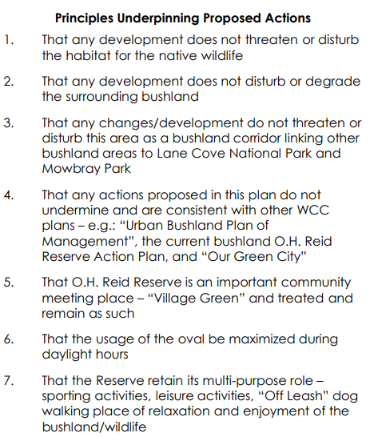

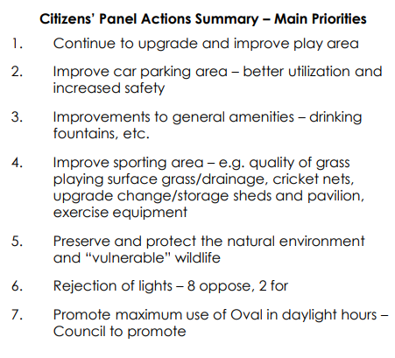
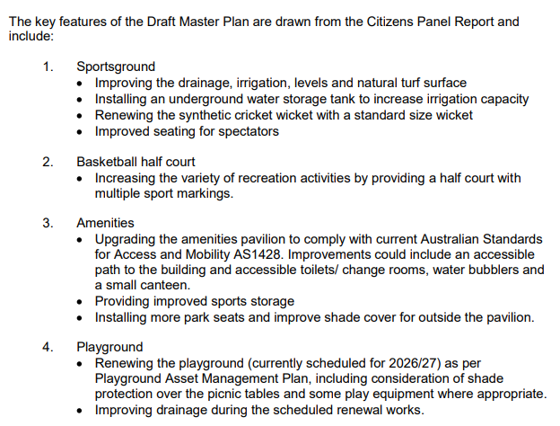
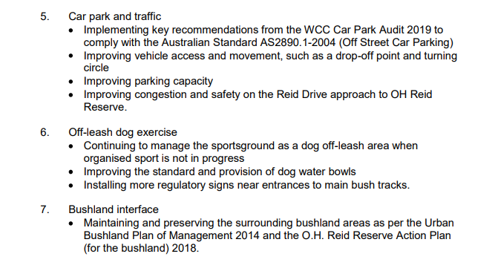
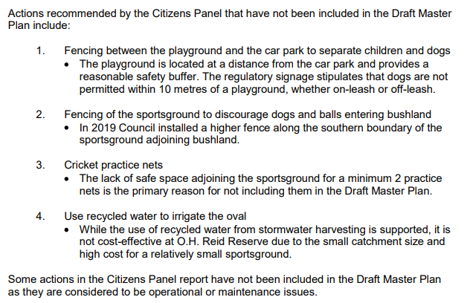
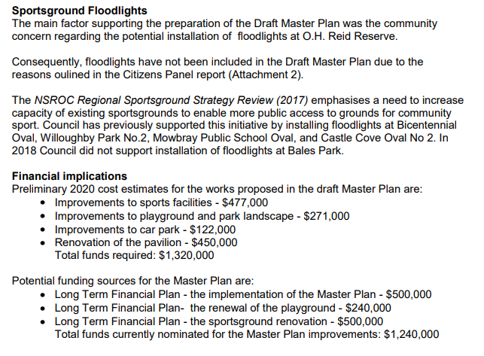
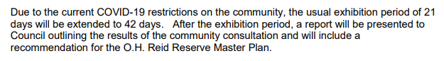

TRAFFIC & TRANSPORT
Pacific Highway problems: In early December 2019 we wrote to the Premier:
The Chatswood West Ward Progress Association (CWWPA) via the Willoughby Council Traffic Committee (where you are represented by Mr. Ken Rutherford) and Willoughby Council have been lobbying the Roads and Maritime Services (RMS) over a number of years to get resolution of the problems that plague this stretch of Road. In a recent study, the road was judged to be the third worst section of road in Sydney from a safety and crash perspective. At the last meeting of CWWPA it was resolved that we write to the Local Member (Premier) advising that the Pacific Highway between Boundary Rd and Mowbray Rd and especially between Fullers Road and Albert Avenue is a known traffic black spot. We would appreciate advice from yourself on what your government is doing to address this issue.

We have received the following advice from the Minister for Transport and Roads. It appears that our lobbying has generated at least some changes to be implemented.
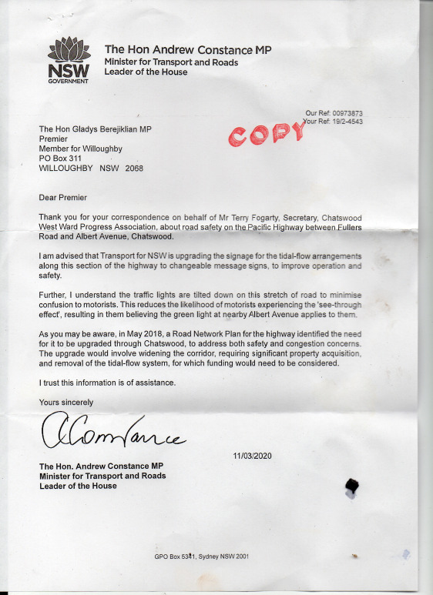
From what we can make out a “changeable message sign” is some form of electronic sign such as the ones below:
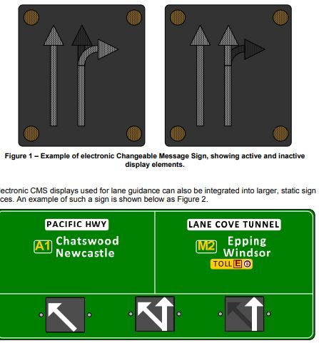
We are hoping for over the road gantries like along Military Rd.
Changeable Message Signs (CMS) are used in permanent positions above or adjacent to the roadway for lane designation or traffic management applications in New South Wales.
Whilst the Minister mentions some changes that have been made for city bound traffic on the Highway (traffic lights tilted down), nothing seems to be planned to control traffic exiting Albert Avenue approaching Centennial Ave.
Evidently, this is all the changes to be made as whilst an upgrade has been identified as being needed, there is no funding available.
Sadly, state elections are not scheduled until March 2023.
Anderson, Victoria and the Mall: We resolved to write to Council regarding problems with traffic and pedestrian movements at these locations. We received a swift response from Council traffic engineers on this matter:

Thank you for raising the issues in Victoria Avenue and Anderson Street in Chatswood CBD. The Progress Association concerns and suggestions are noted. Investigation will be undertaken of the issues raised by the Progress Association. Consultation with Council’s Ranger Section will also be undertaken. If problems are identified, options will be considered, including the suggestions provided, and feasible, cost effective and acceptable proposals identified. Potential improvement proposals will be developed and community consultation undertaken to understand the level of community support. Where appropriate proposals will be considered by the Local Traffic Committee, Council approval sought and funding requested to implement any approved improvements.

DEVELOPMENT
New planning legislation: Clr. Saville has given notice to Council to move the following motion: That Council writes to the Minister for Planning Rob Stokes MP and the Premier Gladys Berejiklian to express its opposition to the recent changes to the Environmental Planning and Assessment Act which grant the Minister unprecedented powers to override planning decisions made by local councils.

Chatswood Education Precinct: We have included a detailed comment by a resident on the proposed upgrade as an Appendix.

GENERAL BUSINESS
Support for indigenous communities opposing fracking in the northern territory: Clr. Saville’s motion to Council which was lost is included as an attachment along with the Council Officers response to the motion.

The voting on the motion was equal number for and against. The Mayor had voted against the motion. The Mayor elected not to use her casting vote. That being the case, the motion is deemed lost.

Request from Cammeray Public School P& C to support their request for the Western Harbour (and Beaches Link) EIS process to be suspended until after the COVID-19 crisis has passed. This request was considered by the Committee but not supported.

Business support plan: Willoughby City Council’s Business Support Plan, worth up to $1.66 million over six months, was approved at an extraordinary meeting last night.
It offers relief on rents, fees and penalties to help support local businesses and community groups through the COVID-19 pandemic.
The Business Support Plan includes:
• Rent relief for Council’s restaurants and cafes tenants totaling $573,000 over six months.
• Waiving licenses and fees for sporting organisations for up to six months, saving them $600,000.
• Relaxing some infringements that don’t impact on health or safety (e.g. overstaying a parking meter), valued around $55,000
• Fee concessions for 6 months equating to about $435,000, including:
o waiving some environmental health inspection fees (but not those that directly relate to food hygiene), fire safety fees, footway dining and advertising fees
o a 50% fee reduction for Chatswood Mall Market stallholders
Mayor Gail Giles-Gidney said the Business Support Plan was flexible so it can be revisited if there are further health orders, or benefit from other government assistance.
“We’re in tough times so we moved quickly to create a plan with maximum financial benefit to offset those impacted by the COVID-19 outbreak while ensuring continuation of critical functions and health and safety,” Mayor Giles-Gidney said.
“We recognise the deep and long term impacts of COVID-19 on local small businesses and the flow-on effects to our community.
“A report outlining what we are doing for vulnerable members in our community was also presented to Council.”
To ensure agility and to respond more quickly, the Mayor and Chief Executive Officer were delegated joint authority to make changes to the Business Support Plan as needed.
Councillors also a considered a financial strategy to understand the impacts on Willoughby City Council’s bottom line and manage risk, while supporting the community and maintaining major projects.
Online library: At our request the Library has contacted those suppliers to see whether external use may be possible.

The publishers of The Sydney Morning Herald, The Age and Financial Review do not make their newspapers available outside of the Library. However you can access the Sydney Morning Herald from home with your Willoughby Library card via the State Library NSW eResources or contact library staff for help.

Ancestry.com is now available to library members at home instructions to connect to Ancestry are on cwwpa.org or contact library staff for help.

The publishers of Choice have been contacted to see whether accessibility could be changed in the circumstances. If the library is able to offer this service outside the library, information will be posted online.

5G communications: Clr. Saville has listed a motion at Council s calling for support a moratorium on the installation of 5G technology infrastructure until the previously requested information is provided, including:

SUPPORTING INFORMATION PROVIDED BY THE COUNCILLOR: The deployment of 5G in the absence of adequate safety testing is a violation of the Precautionary Principle. An urgency motion was unanimously passed by the Byron Shire Councillors on the 19th March 2020. Council minutes: The siting of towers emitting EMR has been an on-going concern to local residents and workers within WCC.

OFFICER’S RECOMMENDATION: That Council note the information provided on the Parliamentary Inquiry into 5G in Australia and the Australian Radiation Protection and Nuclear Safety Agency’s (ARPANSA) submission to the inquiry.

Correspondence OUT/IN – handled in Agenda.

Our next scheduled meeting is for around Thursday 21st May 2020 depending on COVID-19 restrictions.

APPENDIX
Chatswood Education Precinct

We have received the following comments from a resident.
SSD 9483 Chatswood High school redevelopment
These proposals are a substantial improvement on those first presented. When
finished, the new infrastructure will be an impressive addition to our education
capacity.
It is best I don’t comment on the overall calibre of the consultants reports (there is
reference in one report to manually operated windows ‘in bedrooms and living
rooms’; and in the social impact assessment doc. there is reference to 4 and 8 story
residences to the West of the High School – yes, if you go out as far as Ryde!)
There are several questions (in red) that I would appreciate answers to in good time
for me to submit a response to DPIE within the stipulated timeframe.
Traffic reports
These reports are a clear validation that desktop theory fails miserably to
comprehend reality. Further, it is readily apparent that the authors are responding to
a particular commission.
As example, to suggest that the average delay driving from Centennial Ave to Albert
Ave. at peak AM and PM times is 28 seconds is an irrelevant nonsense. The traffic
at these times backs up into Centennial Ave. as far as Dardanelles Rd. I know from
multiple experiences that it can take in the order of 15 minutes from my home on the
Western boundary of the High School to exit to Pacific Highway and thence to Albert
Ave. – a short 400m trip.
The photographs appear to have been selected to present a situation that is far from
the norm.
The report fails to recognise the breaches of law, congestion and frustration that
takes place daily right now, let alone when this road system will need to
accommodate more than double the current student numbers.
The report’s analysis of parking is unbelievable – literally. Figure 2.5 in the Traffic
Impact Statement that purports to show the existing vehicle and pedestrian access to
the High School is wrong.
The document fails to report on, much less provide remedies for, the extreme
difficulty ratepaying residents of Centennial Ave. and other adjacent streets have in
finding parking adjacent their own homes. Indeed, it appears to propose that the very
few existing unrestricted parking places will be changed to short-term parking.
Nor does it refer to the multiple occasions when residents find cars parked, locked,
and empty in their private driveways for long periods of time. This happens because
parents are already unable to find parking to drop off and pick up their children. And
that is now, before the student numbers more than double.
The report fails to recognise the very large number of buses involved in sporting and
other interschool events that need to park and navigate these narrow roads. I have
previously sent you a photograph of one such occasion where 6 buses were parked in Centennial Ave. – three of them illegally double parked. That was not an isolated
incident.
When will we see a realistic traffic impact statement and realistic remedies? Are the
recommendations contained in the traffic reports to become a requirement, or will
they remain some nebulous recommendation that may, or may not, be
implemented?
Building T
Whilst other buildings are detailed in the design analysis report (and artists
impressions are provided), that is not the case for building T. Beyond simplistic
outline drawings there is nothing that would inform the reader as to the visual
perspective of building T. We are simply told it will be brick, concrete and glass.
During the last briefing I was assured building T would be constructed of sound
absorbing concrete panels specifically designed for these situations. What will
Building T be constructed of? What external design principals and features will be
used? What will building T actually look like?
The western wall of building T is approx. 50 metres long, two stories high and with
the roofline above that, and broadside on. It sits high on elevated land and presents
massive bulk to those properties located on Dardanelles Rd. Yes, there are trees to
break the visual impact, however from the drawings it appears that this wall will be a
flat, uninterrupted panel devoid of any architectural features or visual relief. What
architectural features will be incorporated on the Western wall of Building T?
Please confirm your earlier advice that this building will not be airconditioned. If it is
to be airconditioned, where will the A/C plant be located, and how will it not affect
neighbours in respect to noise?
The plans show a series of horizontal lines at the top of the Western walls. Are
these solid glass panels or ventilators? If ventilators how has that been
accommodated in the acoustic report?
What machinery will go into the ‘Plant room’ and how is that acoustically shielded?
There are two sets of doors shown on the lower ground floor of the West elevation.
Either side of the doors is what appears to be some form of ventilation. What is the
detail of how the ground floor doors are constructed, what potential exists for noise
transmission, and how that will be mitigated?
The report speaks of a lift in Building T yet none is shown in the plans. Is there a lift
in building T, and if so where is the machinery located, and what neighbourhood
acoustic impact will it have?
Building S
Building S in part replaces existing building C. As I have already discussed with you
there is a security light on Building C that shines directly into our kitchen and living
room. The report speaks only in generic platitudes about security lighting. It states
that there will be an increase in security lighting, but nowhere does it say where this
will be sited. I was assured that the SEARS report would be specific on this subject – it is not. What, specifically, is planned in respect to security lighting to prevent our
home (and our neighbours) from being flooded with high density light at night?
Acoustic report
‘Logger Location ‘B’, Logger Location ‘D’ and Logger Location ‘E’ were located on
residential presmies (sic) in close proximityto (sic)the School sites. Logger Location
‘E’ was only able to be located on residential premises across from the hall at the
Centennial Avenue Site’. The chosen acoustic logger site E is considerably further
down the road than the proposed site of Hall T. It is also well to the West of those
properties on the Eastern side of Dardanelles Rd. that are adjacent Hall T. The
topography at this point is a very steep downwards incline to the West. The site
chosen is low even relative to Dardanelles road and very substantially below the
level of the proposed hall. In fact, it is the very lowest point in Dardanelles rd. One
must wonder why that site was chosen. It is the site least affected by noise from the
school. No request was made to have the logger located in my property, nor, as far
as I am aware that of my neighbours. Why was the logger E sited at that place?
‘A typical use of the Hall outside of School hours is assumed to be as follows:•Disco;
1 to 2 a year from 3pm to 7pm•Band 1 to 2 times a week 8am-9am in hall•Year 6 /
Year 12 farewell –1 x per year•presentation nights –2x per year•OOSH; Monday –
Friday; 30-50 kids –3pm to 6:30pm.’ This bears little relationship to the current use of
the existing facility, let alone once the new hall T is operational. Amongst other
outside uses there is regular band practice after hours and on weekends (note: the
report states the band will be 8am – 9am which is a nonsense), and religious
services. There are also music festivals and other community events that are not
identified in the report. There is no reference to the hall T being used for sporting
events (albeit it is designed to do so) and no reference to noise from cheering
supporters. This will occur both during and after hours and on weekends. What will
be done to ensure the acoustic report properly reflects the reality? What assurances
do the neighbours have that noise emanating from this building T will be, and will
remain, within accepted limits?
‘We recommend that use of the halls be restricted to daytime and evening period of
7 am to 10pm only’. Are these recommendations to be made a requirement of
approval, or are they a platitude of the possible?
‘R8 –7 DardanellesRoad, Chatswood4240No (+ 2 dB) The majority of the air
conditioning condenser units are able to meet the acceptable noise level, with the
exception of Residential Receptor R8. The slight exceedance based on typical
condenser units would be able to be designed to reduce the level of noise emission
at this location.’ This is R8 is adjacent my property. Specifically, where will this
referred AC unit be located. Will it, or will it not, be a requirement that it be
acoustically shielded.
‘Once the mechanical plant selection has been finalised, a final assessment should
be made of the mechanical plant noise emission, prior to the issue of a Construction
Certificate.’ Will this be a requirement of the approval, or is it just another nebulous
suggestion?
Rainwater drainage
The proposed drainage plan calls for gutter/downpipe runoff from buildings Q,S,J
and T to be decanted into a pit near the Northwest corner of the site (near the North
end of Building T). The report uses theoretical desktop calculations in respect to the
capacity of the system. As I have already advised, even in moderate rain this pit is
inadequate. We experience water bubbling up either side of the pedestrian footpath,
from under our drive, and between drive and roadside kerb. What will be done to
ensure adequate rainwater drainage exists?
Sewerage
As advised previously, we have had problems with the school’s sewer line running
adjacent our Southern boundary. By way of theoretical calculation, the report states
categorically that the existing system is satisfactory for the proposed future use. And
yet their own Site survey High School Part 1 page 8 states that they were unable to
access the sewer pit on the NW corner and that further down the line they were
unable to use the ’flexi rod’ due to obstruction. Clearly there is a problem. What will
be done to ensure we do not have high school sewerage flooding our property as
has happened in the past?
Fencing
The report states that North of building T there will be a ‘New 2.1m high security
fence to driveway and along northern side of carpark. New vehicular access gate
and pedestrian (sic) will be required.’ Fair enough, but that fence for some reason is
shown running approx. 2m inside the actual boundary leaving a narrow path
between boundary and the fence. What is the reason for the fence on the NW corner
of the site not following the boundary?
Question summary
• When will we see a realistic traffic impact statement and realistic remedies?
Are the recommendations contained in the traffic reports to become a
requirement or will they remain some nebulous recommendation that may, or
may not, be implemented?
• What will Building T be constructed of?
• What will building T actually look like? What external design principals and
features will be used?
• What architectural features will be incorporated on the Western wall of
Building T?
• Is there a lift in building T, and if so where is the machinery located, and what
neighbourhood acoustic impact will it have?
• Are the panels at the top of Building T walls solid glass or ventilators? If
ventilators how has that been accommodated in the acoustic report?
• What machinery will go into the ‘Plant room’ and how is that acoustically
shielded?
• What is the detail of how the ground floor doors (building T western side) are
constructed, what potential exists for noise transmission and how that will be
mitigated?
• Is there a lift in building T, and if so where is it located, and in what way will it
not affect the neighbours with noise?
• What, specifically, is planned in respect to security lighting to prevent our
home (and our neighbours) from being flooded with high density light at night?
• Why was the logger E sited at that place?
• What will be done to ensure the acoustic report properly reflects the reality in
respect to building T?
• What assurances do the neighbours have that noise emanating from this
building will be, and remain, within accepted limits?
• ‘We recommend that use of the halls be restricted to daytime and evening
period of 7 am to 10pm only’. Are these recommendations to be made a
requirement, or are they a platitude of the possible?
• The slight exceedance based on typical condenser units would be able to be
designed to reduce the level of noise emission at this location.’ Will it, or will
this not, be a requirement of the approval. Specifically, where will this
referenced AC unit be located
• ‘Once the mechanical plant selection has been finalised, a final assessment
should be made of the mechanical plant noise emission, prior to the issue of a
Construction Certificate.’ Will this be done or is it just another nebulous
suggestion?
• What will be done to ensure adequate rainwater drainage exists?
• What will be done to ensure we do not have high school sewerage flooding
our property as has happened in the past?
• What is the reason for the fence on the NW corner of the site not following the
boundary?

