minutes

Chatswood West Ward Progress Association
Thursday 19th August 2021

The President welcomed members.

Acknowledgement to country by the Secretary: We acknowledge the Aboriginal people, the traditional owner/custodians of West Ward country. It is, was and always will be Aboriginal country,

Declarations of interest: Secretary re CHS fence. Daughter works at Dept. of Education Infrastructure; Clr. Campbell – SNPP member; Alan Hall-Watson – Chatswood Gold nClub

Members Present. Fourteen

Apologies : Peter Hayes; Diana Prtde

- Minutes: The following corrections were requested for the July Minutes. 1. That Clr Campbell’s full report be included with the Agenda for the August meeting (accepted) 2. It was agreed (Meredith Foley would be contacting the council candidates and preparing early online material on the candidates (for website; email notification; use of Willoughby Living Diana Pryde agreed to assist on this activity. The reason was that it would not be as worthwhile to put into the printed edition as it would not get out before many had pre-polled. (accepted).
It was MOVED that the MINUTES of the July General meeting having been distributed, be accepted as amended above. Moved: Secretary, Seconded Treasurer: Accepted.

- Treasurer’s report: The financial report was were distributed prior to the meeting. Treasurer spoke to his report. Since the end of July iTreasurer msurance details have been received from the FWPAs. Volunteer Insurance has decreased from $140.00 to $126. This was due to an addition PA opting in the scheme. .Moved that the July 2021 Treasurer’s reports be accepted – Seconded: Secretary. Accepted.

- Any urgent items not included in the Agenda? Traffic report. Meeting with Mayo5 & CEO. Booking Dogherty Rooms.

- REPORTS FROM COUNCILLORS
Any report submitted by a Councillor will be included in full in the Appendix. Any comments by Councilllors during the meeting are not Minuted..

4.1 Clr. Campbell spoke on the following matters – detailed report in Appendices

- Lockdown Changes & Updates – UPDATE
- COVID support plan – UPDATE
- New Draft LEP & DCP – UPDATE
- Moriarty Rd / Bowen St planning proposal – UPDATE
- Laneways Upgrades in Chatswood CBD - UPDATE if any
- Dougherty Centre Upgrade – UPDATE if any
- Local traffic / parking changes proposed – UPDATE
- Proposed Data Centre on Mowbray Road West – UPDATE
- 99 Beaconsfield Rd & 22B Greville St. – UPDATE if any
- Concourse Cladding Replacement Project – UPDATE if any
- Planning proposals in currently under consideration – UPDATE
- VPA policy – UPDATE if any
- Rangers – enforcement, activities
- IPART population growth / supplementary offsets – UPDATE if any
- Bike path fullers Rd – UPDATE if any
- End of trip facility Chatswood station – UPDATE if any
- Infrastructure Works in West Ward – UPDATE
- Infrastructure Contribution Reform – UPDATE
- Additional items out of West Ward – There are also a couple of items of outside of West Ward that may be of interest: UPDATES

- Artarmon Pavilion – UPDATE
- GPS on trolleys
- Channel 9 site
- Asbestos removal SES site

Both Clr. Campbell,’s July and August reports are included in the attachments

- WILLOUGHBY COUNCIL MATTERS

  - Proposed changes to infrastructure funding by developers: We received a thank you note from the Mayor on our correspondence.
  - Election of Deputy Mayor: Clr. Campbell, one of two candidates, missed out after anequal vote and the successful candidate was drawn from the ‘hat’. Craig will stay Deputy until 4 September. So the new Deputy may only serve one month if elections go ahead on 4 December. It was moved, secnded and carried that Clr. Campbell be thanked for his work as Deputy Mayor..
  - Willoughby identity signage: For some time a revision of signs used on main roads to identify entry to Willoughby has been investigated. A report on this matter concluded that The City Signage program has not progressed as it is currently not funded, but could be re-invigorated. The Officer’s recommendation was for the report to be noted. (so nothing likely to change until a budget is allocated).subject to Council endorsement of funding in future budgets.
- STATE GOVERNMENT MATTERS

6.1 Planning for Sydney’s growth: Details of the Sydney Commission’s plans for growing Sydney are available on cwwpa.org under Latest News.
6.2 Cut senior bureaucrats salaries: A survey by the Institute for Public Affairs found that the majority NSW citizens fed up with the financial pain of lockdowns agreed that the salaries of politicians and bureaucrats who earn more than $150,000 p.a should be docked by 20% for the duration of the Greater Sydney lockdown.
6.3 New Consolidated Housing SEPP
The State Government is proposing to consolidate existing housing legislation including for Affordable Rental, Seniors Housi9ng and Affordable Housing. The legislation will also include short-term rental accommodation and social housing provisions. There is new style of housing termed ‘co-living’, a form that provides small private rooms, possibly with kitchen and bathroom facilities (so a higher density of living). Changes are also proposed for boarding houses.
The reasons given for the changes include to facilitate the delivery of more diverse and affordable housing types. and to ensure that the home building sector is well-placed to assist the economic recovery of NSW following the COVID-19 pandemic. There is concern that economic imperatives will override existing community protections.
Full details: https://www.planningportal.nsw.gov.au/housing-sepp
- CWWPA GENERAL MATTERS

7.1 Listing matters for inclusion in the Agenda: We encourage members to put forward matters for inclusion in the Agenda. This could be by way of an item of interest to other members or a notice of motion. Please provide a short (100 words) background note. Such matters must be sent to the Secretary by 6 PM on the Sunday before a meeting.

- FEDERATION OF WILLOUGHBY PROGRESS ASSOCIATIONS

8.1 Report from 7 August meeting: The Secretary (who is the President of the Federation gave a report assisted by the Treasurer.. Matters covered included – Cumulative impact of development; Community Participation Plan; Publication by Council of Private Information; Harbour Tunnel & Beaches Link; Environmental Assessment to include local groups; Developer Infrastructure Levies; Councillor attendance at meeting and briefings; Meet the candidate meetings and extended construction work hours.

A response from the Premier and Minister for Planning and Public Space on the cumulative impact of development is included as an attachment.

8.2 Council elections: Council Elections have been postponed until 4th December 2021 (Refer letter from the Minister in the Appendix).

- HERITAGE
9.1 History of West Ward: A new article ‘Dumping on West Ward’ a history of major contaminated sites has been placed on cwwpa.org the under the History tab.

- ENVIRONMENT & OPEN SPACE
10.1 Environmental assessment: Letter sent to Miinsdter for Environment and Premier (copy to FWPAs) requesting that the protection of local communities, native flora and fauna during should be improved by legislated obligating for those preparing Environmental Impact Statements to make direct contact with the local community and environmental groups and with the bushland/biodiversity staff in local Councils. This would allow those with expertise in the area to share this local knowledge in order to protect our urban bushland and wildlife when development is considered.

11. DEVELOPMENT
11.1 Transfer of development potential: The issue of developers gifting land to council if the benefits of development of that site could be transferred to another site they owned. Was raised at the last meeting. John Hayes plans to propose a motion on this matter.

11.2 503 Victoria Ave (DA2020/311): Behind the Leura Building on the highway. A narrow block recommended for approval for 4 storey commercial building. Peter Hayes may provide additional information in due course.

12. TRAFFIC & TRANSPORT
12.1 Fullers Rd: Letter sent to Minster for Roads and Premier regarding Fullers Rd surface. Some potholes seemed to have been filled.

12.2 Local Bus stops: A member the issue of responsibility for local bus stops. He received a response from State Transit that included (inter alia) the following:All upgrades in relation to footpaths are installed & maintained by local councils. Lane Cove Council and Willoughby Council have rolled out an upgrade project with the aim to have all Bus stops in the area be DDA (Disability) compliant. In regards to signage this is all updated & maintained by Transport for NSW.

The full response from State Transit and correspondence oin the matter from Clr. Saville will be included in the Minutes.

12.3 Traffic Committee report; The Treasure reported: August 2021 WCC Local Traffic Committee Meeting-18 August

12.3.1 – Wombat crossing upgrade in West Ward

Council is in receipt of $1.95 million from the Federal Government Stimulus Commitment Road Safety Program (School Zone Infrastructure) for the installation of 13 raised pedestrian crossings (Wombat Crossing) including upgrades to 11 existing pedestrian crossings and 2 new crossings in the Willoughby LGA.

The August meeting approve the concept design plans of 5 new wombat crossings and associated works including street lighting, regulatory signs and pavement markings, two of the five were in West Ward:

1) Hatfield Street between Mowbray Road West & Farran Street, Lane Cove North

2) Kirk Street at Archer Street, Chatswood.

For more information see the Traffic Committee agenda on the council website.
12.3.2 – Conversion of 5 parking spaces in Railway Street, Chatswood to full time bus zone
I raised at the traffic committee the removal of 5 car spaces in Railway Street (near Help St) and conversion to 24 hour per day full time bus zone.
The council advised this was a temporary change for rail replacement bus plan for rail/ metro maintenance works.
I raised the concerns previously discussed at CWWPA meetings where there was concern at the expansion of the western side bus interchange from its current footprint. I also raised concerns about the blanket approach (24 hour bus zone) and is there a reason the current east or west bus interchange could not be used. I asked if the current east or west bus interchange could not be used, if Transport for NSW could look at more limited bus zone during the hours that where needed and allow vehicle parking at other times.
Council have requested TfNSW review the newly implemented temporary full time bus zone. Will update when a response is received.

- GENERAL BUSINESS

13.1 Chatswood Education Precinct - Fencing: Letter received from School Infrastructure advising the status of the palisade security fencing around the school The letter did not address the concerns we expressed. (Refer Appendix for letter)

13.2 Save RNSH: A link to a petition to save the hospital from overdevelopment has been placed on cwwpa.org under LATEST NEWS..

13.3 Food fines: It is difficult to decide the real situation. Do we rate highly because our rangers are very good? Or is5 this the tip of the iceberg (lettuce)?

13.3 Food fines: It is difficult to decide the real situation. Do we rate highly because our rangers are very good? Or is5 this the tip of the iceberg (lettuce)?

13.4 Kerbside collections: Pre-booked and mattress collections have resumed.

- ADDITIONAL MATTERS ACCEPTED AS URGENT BUSINESS (IF ANY)

14.1 Meeting with Mayor & CEO: The Secretary and Vice President (Diana Pryde) will attend this quarterly meeting.

14.2 Dougherty room booking. Tentative booking have been made for 2022.

- SPECIAL BUINESS

Clr. Campbell declared an interest in this matter due to his membership of the SNPP.

15.1 Sydney North Planning Panel - Chatswood Golf Club: The development was approved. Meredith Foley spoke on behalf of WEPA and CWWPA. David Friend also addressed the panel. Both were very disappointed with the process and lack of acknowledgement of issues they raised. Both expressed concern about the environmental impact of the proposal. Meredith highlighted the lack of procedural fairness (they were not allowed to read their submissions) and were not allowed follow-up questions. It appears that none of the requested additional conditions of consent were granted. David Friend who also addressed the panel reflected a similar perspective. Detailed report are in the Appendices.

There was some discussion regarding environmental impacts and contamination impacts.

OUR NEXT MEETING: is scheduled for 7:30 PM Thursday 16th September 2021 by ZOOM

MEETING TO CLOSE by 9:00

APPRNDICES

4.2 Clr. Campbell’s JULY Report

Report by Deputy Mayor Craig Campbell – July 2021: Please find herewith some updates on various matters concerning West Ward.

- Lockdown Changes – the COVID lockdown has resulted in the following temporary changes:
- Lights are being left on until 8pm at the parks below:
  - Mowbray Road Public School Oval
  - Rotary Athletics Oval

- The following facilities are closed until further notice:

  - Customer Service Centre at 31 Victor Street
  - Dougherty Centre
  - Willoughby Leisure Centre
  - Willoughby Libraries – Chatswood and all branches
  - MOSAIC
  - All sportsground pavilions
  - Art Space on The Concourse
  - Incinerator Art Space
  - Dougherty Centre café (Blend)
  - Chatswood Youth Centre
  - Willoughby Park Centre
  - Zenith Theatre
  - Joe Ciantar Music Rehearsal Studio
  - Unstaffed Community Facilities (West Chatswood, Naremburn, Castle Cove and Artarmon)
  - The Concourse - ticketholders for cancelled performances will be contacted regarding refunds.

- Long Term Financial Plan – An updated long term financial plan was adopted by Council at the July meeting, which takes the negative COVID effect into account. The highlights of it are:
- The budget is balanced, and the 2020/21 financial year results will show a break-even. This is impressive considering COVID accounted for a $14 million revenue drop.
- Council is financially sustainable going forward and will be able to meet service targets whilst delivering promised capital works projects.
- Rates will not change (other than the usual CPI adjustment)
- Infrastructure Levy Will Lapse as Planned – Also included in the long-term financial plan is the assumption that the infrastructure levy, approved by IPART for 7 years commencing in the 2015/16 financial year, will lapse in the 2022/23 year as planned. Rates will go down at that point in real terms. The infrastructure investments have been as planned and are funded at the intended level going forward. The infrastructure refresh backlog has dropped from over $60 million in 2013 to $10 million in 2020, resulting in a backlog ratio of 1.3% (within OLG target of 2%).
- New Draft LEP - The new draft LEP was finalised by Council in December 2020 and submitted to the DPIE for Gateway, which is the next step in the process. There has been no update since last month’s report; the matter is still with DPIE. Once DPIE responds, it will come back for further action and public consultation.
- New DCP – the new draft DCP was finalised and endorsed by Council at the June meeting. It does not need a Gateway determination.
- Moriarty Rd / Bowen St planning proposal – The Final Report has been issued by the Independent Chair of the Public Hearing and this can be viewed on Council’s Website (it basically recommends development outside of current zoning, but at a much reduced scale to what the proponent had proposed). The proponents have indicated they are now considering their future intentions and once known, officers will submit a report to Council. They are still in this process; once done, it will come back to Council. The timing is expected to be August or September.
- Laneways Upgrades in Chatswood CBD - I previously reported several projects underway to improve the amenities of laneways in the CBD, specifically Post Office Lane, Charlotte Lane, Mills Lane, and Spring Place:
These projects are in process and on track for completion by the end of December.
Here is a rending of the design for Spring Place:

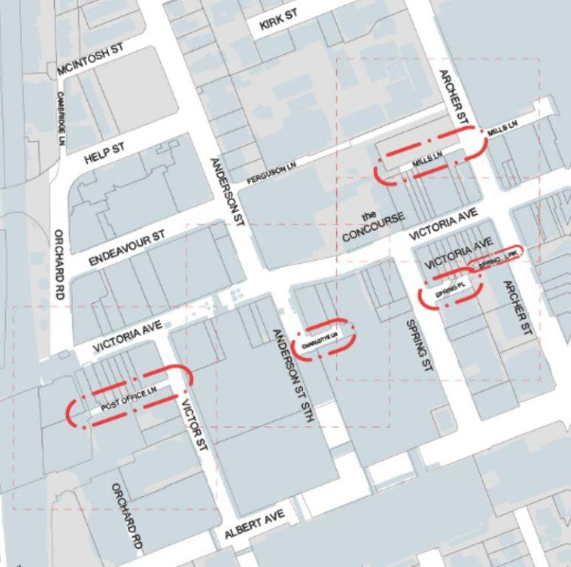

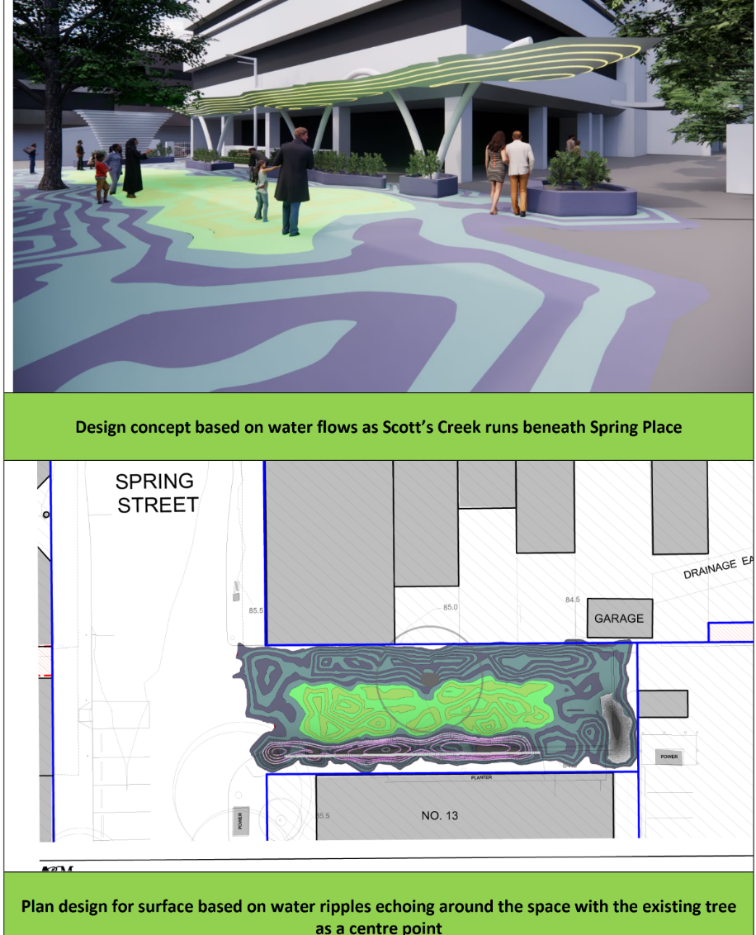

- Dougherty Centre Upgrade – I previously reported an active project to upgrade the Dougherty Community Centre, again using funding from the Local Roads and Community Infrastructure Program Phase 2 Federal funding scheme.
The plan is to update and reconfigure the Dougherty Community Centre internally to increase community and hireable space. This will include a modernisation of the internal design and workspaces. This will increase the capacity to allow for the co-location of the MOSAIC Multicultural Centre at the Dougherty Centre as well as increase its capacity to allow it to act as an emergency evacuation centre.

The works schedule is still on track for an end of December completion. I will update with the final design in due course.

- Local traffic / parking changes proposed – The following initiatives have been progressed in West Ward that may be of interest:

- Proposed changes to parking in Carr St, Chatswood West, were approved by Council in May. They include:

  - Replace the existing 4P 6:30am to 6:30pm Monday to Saturday permit holders excepted Area 6 parking restrictions with unrestricted parking on the east of the road, between Centennial Avenue to the driveway of 78 Centennial Avenue.
  - Implement new 4P 6:30 am to 6:30 pm Monday to Friday permit holders excepted Area 6 parking restrictions on the east side of the road, from the driveway of 78 Centennial Avenue to the driveway of 9 Carr Street;
  - Replace the existing 4P 6:30am to 6:30pm Monday to Saturday permit holders excepted Area 6 parking restrictions with unrestricted parking on the east of the road, from the driveway of 9 Carr Street to De Villiers Avenue.

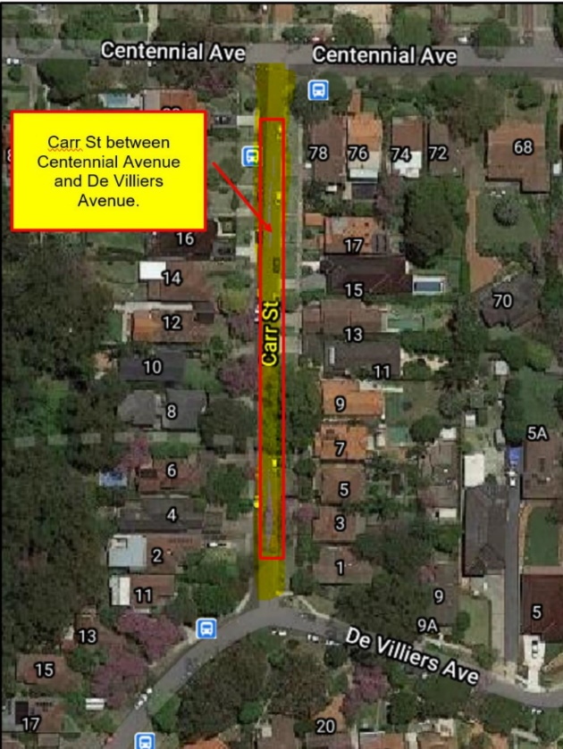

- Improvements to the pedestrian & bicycle shared pathway at Bowen St (to Moriarty Rd), Chatswood, to improve safety from motorbikes cutting through this area to avoid traffic on the Highway.
Consultation was held in June on the proposal to install barriers with hazard warning signs at the entry to the shared path as well as new pedestrian and bicycle logos, ‘slow’ pavement markings, line marking and changes to the existing signs in the shared path.
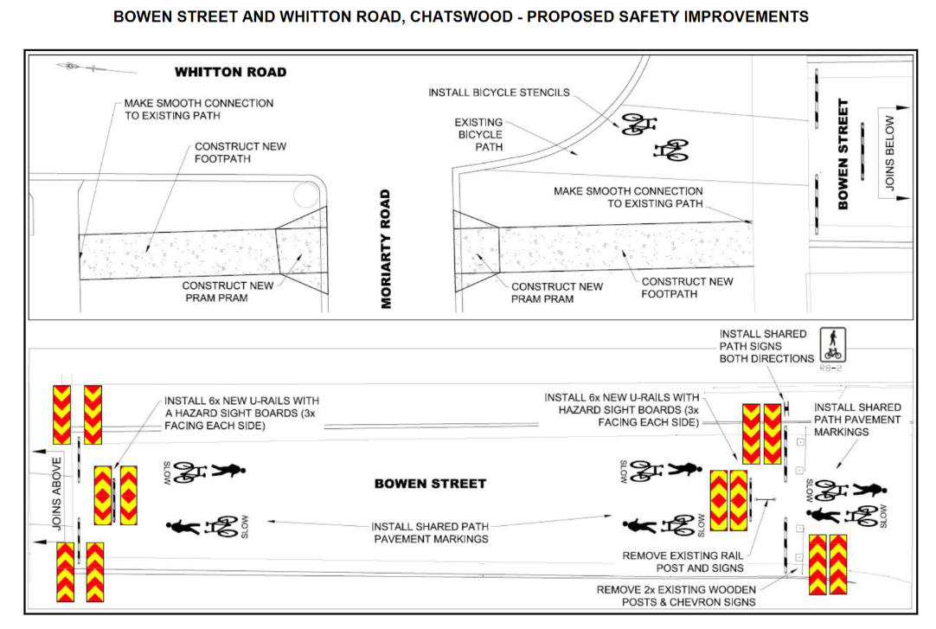
- Installation of a new wombat crossing at Kirk St & Archer St, Chatswood (near Mercy Catholic College) as part of the School Children Safety Wombat Crossing Program:

  - Installation of a new wombat crossing in place of the existing pedestrian (Zebra) crossing in Kirk Street.
  - Removal of the existing kerb ramps and replacement with a 3.6m wide continuous footpath
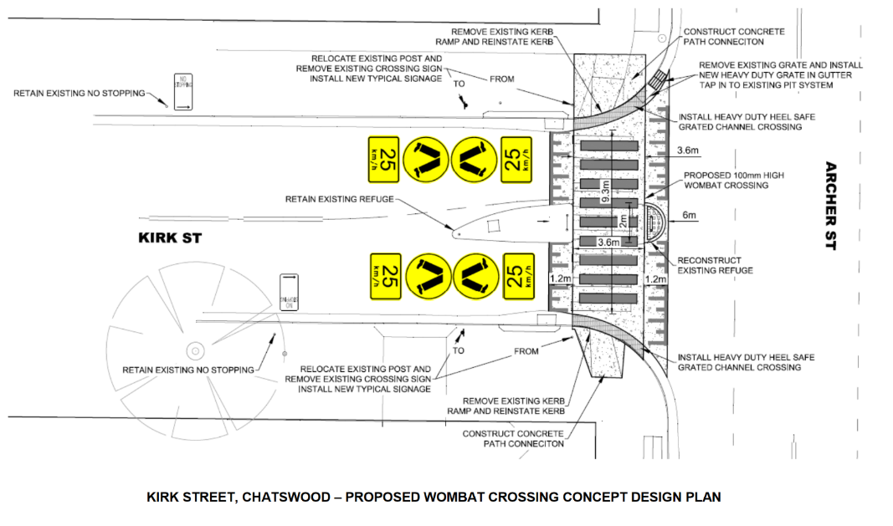
- Installation of a new wombat crossing on Hatfield St, Lane Cove North (near Mowbray Public School) as part of the School Children Safety Wombat Crossing Program:

  - Installation of a new wombat crossing in place of the existing pedestrian crossing on Hatfield Street.
  - Installation of new blister islands and widened kerb ramps and concrete path connections to suit the new arrangement
  - Installation of associated signs and line marking as part of the wombat crossing.
  - Extension by 5.5 metres to the existing full time “No Stopping” restrictions on the east side and 0.5 metres on the west side of Hatfield Street.
  - Loss of one parking space.
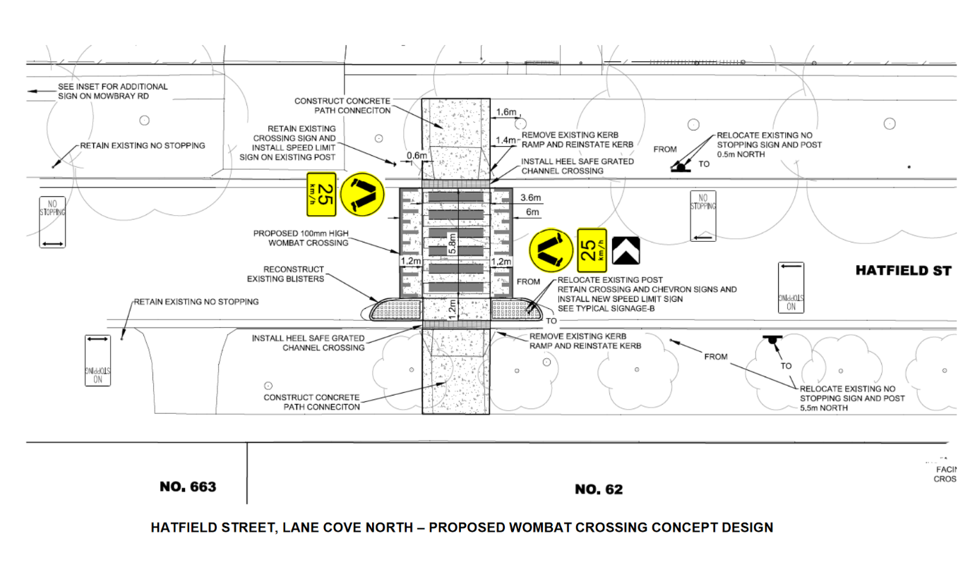
- Proposed Data Centre on Mowbray Road West – There has been no change to this as far as I am aware. It is a project in the Lane Cove LGA which will affect residents in West Ward, however, so I like to flag it to keep everyone aware. Here is a link to see the status of this project: https://www.planningportal.nsw.gov.au/major-projects/project/41041.

The nearby residents are concerned about adverse impacts during the construction phase. Willoughby Council has objected to the size and scale, as well as raised similar concerns to the residents; however, our power to block it is limited.

- 99 Beaconsfield Rd & 22B Greville St. – the DA for a large redevelopment under the seniors housing SEPP was rejected by the Willoughby Planning Panel. The proponent has appealed to the Land & Environment Court, where Council is defending the refusal. A conciliation conference commenced at the end of May and continues, with no outcome so far. If the conference fails, the matter will progress to a full court hearing.

- Concourse Cladding Replacement Project – The replacement of the cladding on the Concourse is underway and roughly 20% completed.

- Chatswood Education Precinct Renovation – Construction is underway at Chatswood High School, temporarily halted by a pair of powerful owls, who were successful in convincing the NSW Department of Education to adapt its plans in order to retain their nesting tree.

- Planning proposals in currently under consideration – I am aware that the following have changed status:

- PP 2016/007/A (65 Albert Avenue Chatswood, Mandarin Centre) – approved by SNPP, permitting a 70% non-residential, 30% residential land use split on the site and the LEP amendment will now move to the final stages to be made.

- PP 2017/003: 629-639 Pacific Highway Chatswood (tyre & brake shop between Gordon Ave & Nelson St, east side of the Highway) - this PP is on public exhibition from 5 July and 2 August 2021. It is next door to the site below (PP2021/004).

- PP 2021/004 (613, 621 - 627 Pacific Highway Chatswood, east side of Highway between Gordon Ave & Nelson St) – approved by Council at the July meeting to forward to DPIE. Commercial / residential mixed use, zoning change to B4, complies with the CBD strategy.

- PP 2020/007 (3 Ellis St Chatswood, west of railway line, behind Chatswood Oval) – refused by Council at the June meeting; rescinded at the July meeting and subsequently approved and forwarded to DPIE. Commercial / residential mixed use in B4 zone; complies with the CBD strategy.

- PP 2020/010 (849, 853, 859 Pacific Highway and 2 Wilson Street Chatswood, SE corner of Wilson St & Pacific Highway) – refused by Council at the June meeting due to inconsistency with CBD strategy.

Also, note that the SNPP delegations have changed so that the Council representatives are now the mayor and the most recent (but not currently serving) deputy mayor. If there is no such former deputy mayor on council, there is a list of community representatives to fill in as alternates (a similar list to the Willoughby local planning panel). This means that as the sitting deputy mayor, I no longer have a conflict on planning proposals before council. The exception to this is the Chatswood Golf Course PP, where I am already a sitting member of the determination panel.

- Infrastructure Works in West Ward – Coming up, the following roads are scheduled for re-sheeting and heavy patching:
- Devilliers Ave between Carr St and Dardanelles Rd
- Centennial Ave between Whitton Rd and Edgar St
- Mowbray Rd between Greenlands & Beaconsfield Ave

Also number of heavy patching works at various locations are scheduled. Elimination of Footpaths trip hazards are on- going.

In terms of drainage, footpaths and kerb & gutters, number of projects will be implemented by incorporating road works.

Previously, between May and June 21, apart from road re- sheeting works, major drainage upgrades in Anglo St, Fullers Rd, Lone Pine Ave and also major new footpath in Fullers Rd under missing links program were carried out.

- Infrastructure Contribution Reform – There is currently a proposal before the NSW parliament to reform infrastructure contributions, shifting costs from developments to ratepayers. The proposed reforms would result in a potential $100 million loss in revenues to Council over 20 years, which under the current system would have gone to support infrastructure resulting from development (under s 7.11 and 7.12). The draft plans and financial modelling have not yet been publicly exhibited. Also, the bill contains very broad powers for the minister to singlehandedly make sweeping changes to infrastructure contributions (including agreements already in place) without consultation.

The bill has passed the lower house and been referred to an upper house parliamentary committee. Council received an invitation to make a submission on the matter on 5 July, with a deadline of 11 July (6 days later).

We did so and objected strenuously to the proposed shifting of costs to ratepayers and the potential shortfalls in funds available for infrastructure investment in the future.

Recommendations included:

- That detailed modelling and assessments of the economic impact be undertaken and made public prior to the bill advancing
- That costs of development not be shifted from developers to ratepayers
- That the bill not progress until credible evidence can be show that no LGA will be worse off under the proposed scheme
- That a requirement be included for infrastructure contributions to be paid at the construction certificate stage
- That the minister not be empowered with sweeping powers to unilaterally make changes to infrastructure contributions without consultation.

- Additional items out of West Ward – There are also a couple of items of outside of West Ward that may be of interest:

- Artarmon Pavilion – Council resolved at the July meeting to proceed as planned with the adaptive reuse of the former Artarmon Bowling Club building.

- Naremburn ward Councillor Stuart Coppock resigned, effective 30 June 2021.

- Follow-up Queries from May Meeting :

- Budget for the Dougherty Centre upgrade:
$1.2 million, thereof $1 million funded by the federal grant; $200k from Council

- Council policy rereplanting of trees, availability of root stock and indigenous plants:
Policy is a 3:1 replacement ratio; this is managed through bush care based at Warners Park, where the trees and indigenous plants are available

- Status of Chatswood Park upgrade plans:
Works remaining to be completed by 31 Dec:
  - Installation of 3 shade structures using the old trusses from Chatswood Station
  - Landscape works on the old site of the Cedric Pike Pavilion
  - Signage
Works remaining to be completed in first quarter 2022:
  - completion of the perimeter path

10.2 Sydney North Planning Panel – reference no. PPSSNH-97 Development Application no.2020/117 by Meredith Foley.

I am a local resident representing members of the Willoughby Environmental
Protection Association (WEPA) and the Chatswood West Ward Progress
Association. Neither of these groups opposes the redevelopment of the golf course
site but we do have concerns regarding:
• the proposed destruction of a significant wildlife corridor
• the number of trees to be removed
• the subsequent impact on biodiversity and
• the level of consideration given to these issues by Willoughby City Council as
part of the approval process.
The proposed development straddles a ridge which currently provides an important
wildlife corridor and habitat for a significantly biodiverse site. The area is identified as
core bushland in Council’s Natural Heritage Register and its importance noted in
Council’s Urban Bushland Plan of Management 1 . The denuding of this ridge and
north and south slopes will create a break in the only uninterrupted, vegetated
corridor linking the high canopy of Ferndale Park and Coolaroo Reserve. It will also
cut linkages to other nearby north and south reserves and to areas along the Lane
Cove River and into Lane Cove National Park.
The removal of a total of 238 mature trees, as well as native grass and understorey,
from the site will remove the route used by local wildlife to move from one reserve to
another. In particular, the removal of trees from the southern side of the slope
outside the building footprint, in order to provide a bushfire protection zone, could
lead to erosion and further damage to the natural bushland in this area.
The proposed planting of replacement tube stock elsewhere on the course fails to
address this problem. They will not reinstate the corridor, will take 15-20 years to
attain any useful height and they can take up to 150 years to provide hollows. There
are also questions about when the plantings will be completed as stockpiling is to be
carried out on the site and further changes are planned for the course itself.
The problems outlined could be addressed if the proponents were directed to
consider a more constrained building footprint.
We also believe that many of these concerns could have been addressed earlier if
Willoughby City Council had given greater consideration to existing state legislation
and policy as well as its own environmental planning instruments. The 3 major
1 ‘Chatswood West and Lane Cove North’, Willoughby City Council, Natural Heritage Register (2016);
Willoughby City Council, Urban Bushland Plan of Management (2014).

planning and environmental Acts 2 all propose that we should be favouring
developments which are ecologically sustainable and - in doing this - “conservation
of biological diversity and ecological integrity should be a fundamental
consideration”.
The protection and enhancement of what we have left, in terms of biodiversity and
urban bushland, is a recurring theme in a wide range of State policies, strategies and
guideline documents 3 and in Council documents such as its LEP; Tree and
Vegetation Preservation Clauses in the LEP and DCP; Urban Bushland Plan of
Management; Natural Heritage Register; and Green City Plan. 4 . . We would argue
that, in the case of this proposed development, Council has not given proper
consideration to its own environmental planning documents and has therefore failed
to correctly identify the importance of maintaining this wildlife corridor and the
biodiversity it supports for future generations. Dr Meredith Foley

13.1 Chatswood High School - Fencing

 | 10:13 AM (2 hours ago)
  Response from School Infrastructure
Dear Ms Fruedenstein-Hayes,

Thank you for your email regarding the newly installed black palisade fence along the Chatswood High School Centennial Avenue boundary.

Palisade fencing is used across many NSW schools and this design is standard for providing effective school security and safety for students and staff. The fencing was requested by the school to assist with managing student safety for students requiring additional support.

The partial setback along the western section of the Centennial Avenue boundary is for that section only and no further work will be completed to widen this setback.

The palisade fence recently installed along the High School’s western boundary, adjoining 60 Centennial Avenue, is temporary. The long term solution for fencing on the school’s western boundary line will be determined when the upgrade project’s landscaping works start. These works are anticipated to occur in early 2023. Prior to this, the team will consult with adjacent neighbours regarding the permanent fence along the western boundary.

The fence design that was submitted in the initial Environmental Impact Statement was a schematic design only. Through the detailed design phase, which included further consultation with the school and the department’s school security unit, the fence design changed to comply with the Department of Education Facilities Standards and Guidelines (EFSG). The previous set back fence did not achieve the EFSG requirements. The fencing plan approved by the Department of Planning, Industry and Environment (DPIE) can be found on the School Infrastructure NSW and DPIE websites under “Stamped Plans” (The plan is named SD-AX-L1701 (P3) ‘Fencing & Gates Plan’ (Slide number 61) and dated 20 November 2020). The stamped plans show that this type of fencing will be continued around the perimeter of the school for the same reasons outlined above, to provide effective school security and to comply with the department’s EFSG. There will be no impact to the Chatswood High School biodiversity zone as previously communicated.

Thank you again for your enquiry and please contact us again should have any further questions.

Kind regards,
Jonathan
Community Engagement Team
P 1300 482 651 | E schoolinfrastructure@det.nsw.edu.au | schoolinfrastructure.nsw.gov.au
Level 8, 259 George Street, Sydney NSW 2000 | GPO Box 33, Sydney, NSW 2001
[Please note: SINSW’s community phone and email lines are staffed only during Monday – Friday: 9am - 5pm]

Local bus stops

Response from State Transit:
Thank you for your enquiry regarding upgraded bus stops and footpaths in the West Chatswood area.
All upgrades in relation to footpaths are installed & maintained by local councils.
Lane Cove Council and Willoughby Council have rolled out an upgrade project with the aim to have all Bus stops in the area be DDA compliant. We would recommend getting in contact with them to discuss anything further.
Unfortunately State Transit Authority has no control or say when council roll out the bus stop up grades.
In regards to signage this is all updated & maintained by Transport for NSW.
Please know that State Transit is committed to providing a professional service to our customers and as such, we really appreciate your feedback in improving the way we operate.
Thank you again for taking the opportunity to bring this matter to our attention.

Kind regards

Rakaia
Customer Relations, Corporate
State Transit

Crrespondence form Clr. Saville
As far as I can ascertain the upgrade was to meet requirements of the Disability Act, and the Disability Action Plan which council prepared.

I did not buy a car until I reached 60 years of age, preferring public transport for environmental and equity issues, so I am absolutely supportive of accessible, safe, reliable public transport.

Re the recent upgrades in Chatswood, west of the highway:

• IMO the upgrades have been undertaken at poorly patronised bus stops. Indeed most of the stops along Centennial, Carr, De Villiers, Eddy, Lone Pine, Dalrymple etc. are used maybe once per day.
• Perhaps fewer stops, with slightly greater distance between stops would have been reasonable. More regular, frequent services may encourage patronage. IMO patronage post covid-19 should be analysed.
• Communication to us and our neighbours was inadequate. We were informed in a general way that upgrades were to be undertaken, but the notice omitted mentioning the stop nearest our house!
• IMO Access has been improved at most of the wheelchair users, and for those with mobility problems.
• The stop near our house in Eddy was re-located away from a corner, to a slightly safer position.
• We and our neighbours were seriously concerned that the new thick, deep cement block and ramp were placed directly over the NBN, Telstra and other services which poses risk and costs for future maintenance. We called/wrote to council & spoke to the workmen re our concerns, who replied that any future maintenance required will be the responsibility of the service provider.
• upgraded bus stops.
• One stop near Eddy/ De Villiers, should have been re-located to a more accessible, level location. It remains inaccessible for those with mobility issues, and wheelchair users.

Local Government Elections

 | 2:13 PM (22 minutes ago)
  OLG BS Response Mailbox <response@olg.nsw.gov.au>
to Presidentfwpa@gmail.com

Doc ID: A783428

Contact: Client Services
Phone: 02 4428 4100

Mr Terrance Fogarty
Presidentfwpa@gmail.com

Dear Mr Fogarty

Thank you for your email of 19 July 2021 to the Minister for Local Government, the Hon. Shelly Hancock MP regarding the 2021 local government elections. I have been asked to respond on the Minister’s behalf.

The Minister announced on 25 July 2021 that the upcoming local government elections will be postponed from 4 September to 4 December 2021 in response to the current COVID-19 situation.

This decision was made after extensive consultation with and advice from the NSW Electoral Commissioner and NSW Health to ensure the safety and wellbeing of communities, voters, polling staff and candidates.

Thank you for bringing your concerns to the Government’s attention.

Yours sincerely

Lindsay Ewens
Leader, Client Services

Office of Local Government | Department of Planning, Industry and Environment
T 02 4428 4100 | E olg@olg.nsw.gov.au
5 O’Keeffe Ave, NOWRA NSW 2541
www.olg.nsw.gov.au

